Follow Spot Overview Name:
Introduction to Stage Lighting Date:
Summer 2009

- What is the purpose of using a follows spot? Think about this and list at least 3 things you can use it for, also listen to your instructor to what it is used for.

a)

b)

c)

- Where have you seen a follow spot used, explain. If not, if you had to use one, how would you use it?

- What is the name of this type of follow spot that you just got training on?

- List the parts of the follow spot that the instructor clearly went over and explain how it is used, keep it simple ladies and gentlemen.

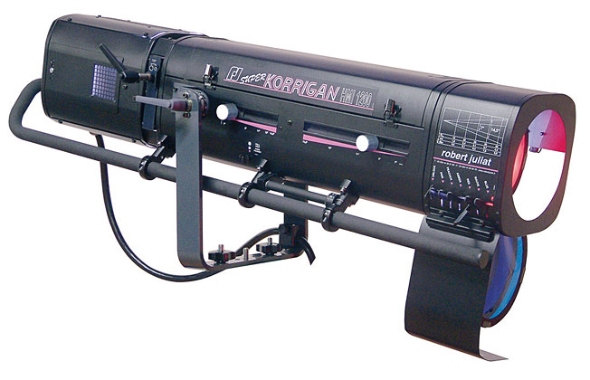
List the parts here:

- How many gel colors does this follow spot able to acquire, not including the no color?

- How are the two ways you can shut the light off the quickly on an object not the power, but by using the follow spot’s attributes/handles or levelers.

- Where is the power supply located for the follow spot?

